SOCIAL MEDIA USER BEHAVIOR PREDICTION REPORT
MACHINE LEARNING & POWER BI DASHBOARD
PROJECT

PROJECT REPORT
BY
MEVINA P.D

DATA ANALYST

UNDER THE GUIDANCE & SUPERVISION OF
Miss AMRUTHA

Palakkad, Kerala, 678702

CONTENTS

INTRODUCTION
ABSTRACTION
OBJECTIVES
METHODOLOGY
DATA ANALYSIS
MODEL DEVELOPMENT & RESULTS
DASHBOARD OVERVIEW
CONCLUSION & FUTURE SCOPE

INTRODUCTION

With the rapid growth of social media platforms, understanding user behavior has become crucial for businesses, marketers, and platform developers. Social media platforms generate large volumes of data related to user demographics, usage patterns, and engagement levels.

This project focuses on analyzing social media user data and building machine learning models to predict user behavior patterns. By applying data preprocessing, exploratory data analysis, and supervised machine learning techniques, the project aims to identify key factors influencing user activity and engagement.

ABSTRACT

This project presents a machine learning-based approach to analyze and predict social media user behavior. The dataset includes user demographic details and platform usage information. Exploratory data analysis is conducted to uncover patterns and correlations among features.
Multiple classification models are trained and evaluated to identify the best-performing algorithm. The results are visualized using an interactive dashboard to support data-driven insights. The project demonstrates how machine learning can be effectively applied to behavioral prediction in social media analytics.

OBJECTIVES

The key objectives of this project are:
- To analyze social media user data using exploratory data analysis
- To identify key factors influencing user behavior
- To preprocess and clean the dataset for modeling
- To build and evaluate multiple machine learning models
- To select the best-performing prediction model
- To visualize insights using an interactive dashboard

METHODOLOGY

Step 1: Data Collection

Dataset collected from a structured CSV source containing user demographics and usage patterns

Step 2: Data Preprocessing

Handling missing values

Encoding categorical variables (Gender, Platform, etc.)

Feature scaling and normalization

Splitting data into training and testing sets

Step 3: Exploratory Data Analysis (EDA)

Distribution analysis of age and usage time

Gender-wise and platform-wise user behavior analysis

Correlation analysis between features

Step 4: Model Building

The following machine learning models were implemented:

Logistic Regression

Decision Tree Classifier

Support Vector Machine (SVM)

Random Forest Classifier

Step 5: Model Evaluation

Accuracy score

Confusion matrix

Classification report

DATA ANALYSIS

Exploratory data analysis revealed significant insights into user behavior patterns. Most users belong to the young adult age group, with higher engagement observed among specific platforms. Usage duration showed correlation with demographic attributes such as age and gender.
Visualizations such as bar charts, histograms, and heatmaps were used to identify trends and relationships between variables. These insights helped in selecting relevant features for model training.

MODEL DEVELOPMENT & RESULTS

Model Performance Comparison
Model | Accuracy
Logistic Regression | Moderate
Decision Tree | Good
SVM | Good
Random Forest | Best
Best Model: Random Forest Classifier
- Achieved the highest accuracy among all models
- Reduced overfitting using ensemble learning
- Provided better generalization on unseen data
Top Predictive Features
- Age
- Daily Usage Time
- Platform Type

DASHBOARD OVERVIEW

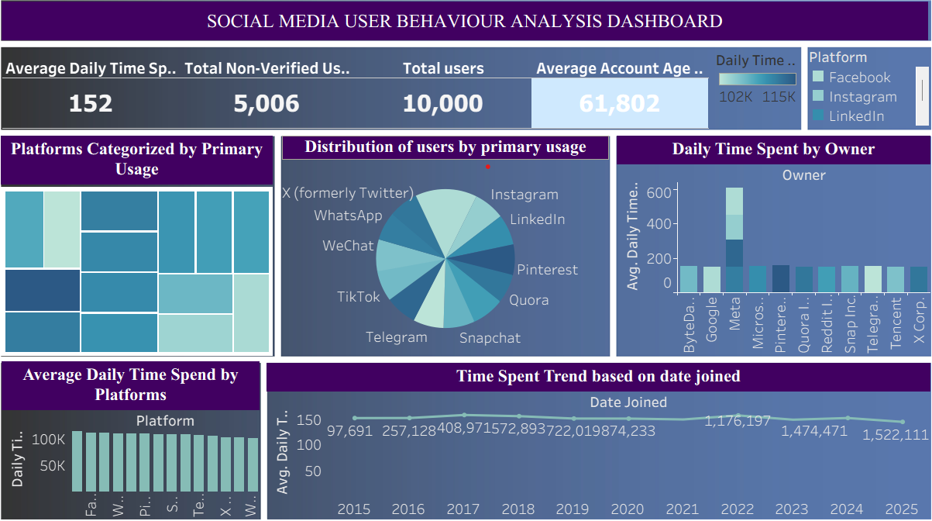

CONCLUSION & FUTURE SCOPE

Conclusion:
This project demonstrates the effective use of machine learning techniques to analyze social media user data. Proper preprocessing, visualization, model selection, and evaluation contribute to accurate predictions. The project highlights how machine learning can be applied to real-world data analysis problem.
FUTURE SCOPE :
- Use larger and real-time datasets
- Apply advanced algorithms like Random Forest
- Improve accuracy with feature engineering
- Deploy the model as a web application

